8/26/2005
Rosebank College
webe
Kwena letlalo
Proposal

Table of Contents
OVERVIEW 1
VISION 1
MISSION 1
Website goals and objectives 1
Key Goals 1
Objectives and key performance indicators 1
Proposed website features and functionality 2
The website will have 2
Design and the user experience 2
Colour design 2
The typography 2
Layout and Design 2
Technical Requirements 2
Programming Languages and the Framework 2
Timeline and milestones 3
Budget 3
WIRE FRAME STRUCTURE 4
Bibliography 5

OVERVIEW
Trecia’s grill is a modern, African- inspired restaurant that provides a friendly, welcoming dinning acquaintance for individuals, groups and families. it was habitual with enthusiasm for mouthwatering and an outstanding consumer service, the restaurant pursues in freshly equipped grilled meals made from superior portions. Trecia’s grill collaborates traditional African tang with contemporary cuisine, stipulating a unique tariff that caters to wide scale of consumers. signature dishes include flame-grilled ribs; seafood; chicken; steak; salads & vegetarian options, all primed to the highest quality. the restaurants’ expedition is to supply consumers with an memorable dining experience by serving delicious, affordable meals in a clean, sizeable and affectionate environment. whether consumers are dining in, requesting takeaways or utilise delivery services, Trecia’s grill is dedicated in supplying excellent food and superb service. Trecia’s grill was established in 2020 by Qana Letlalo in Pretoria and the company’s slogan its African made

VISION
The goal is to become one of the casual dining restaurants in south Africa known for great food top-notch consumer services and real African hospitality.

MISSION
The purpose is to provide meals that are freshly made and of quality with a focus on great grilled food. the aim is to create special dining moments by offering consumer service, new ideas and good value for money.

Website goals and objectives
The restaurant has no online presence and they get the customers though walk-ins only and the only way to get in touch which the restaurant the call only, so the objective of the website is to get an online presence for the business which will increase the availability of the business also making it easier for customers to get in touch with the business and make it easier for poeple to view their menu and order online

Key Goals
- Make an online presence for the restaurant
- Show the menu and dishes
- Make a lead generation though a ordering form
- Give food tips and FQS

Objectives and key performance indicators
- Get an increasing website traffic by 25% in the next 6 months
- Get a minimum of 30 online orders every month
- Have a bounce rate of below 30%
- Be top 1 ranking restaurant page on google for “restaurant in Pretoria”

Proposed website features and functionality

The website will have
- Home page will basic Infor about the restaurant
- About page with information about the restaurant like when it was started
- Food page with information about the restaurant’s dishes
- Contact page with information about how to contact the restaurant
- Ordering page

Design and the user experience

Colour design
Purple(#EA34CB)
White(#FFFFFF)
Glass

The typography
Headings: bold
Body: open scans regular

Layout and Design
- Clean, grid-based structure
- Emphasis on visual content, particularly project imagery
- User-focused features, such as sticky navigation and mobile responsiveness
- High-contrast buttons to ensure accessibility
- Logo and navigation bar
- Hero image with prominent tagline and request quote button
- Services section with icons and descriptions
- Portfolio grid
- Testimonials slider
- Contact form with integrated map
- Footer with quick links and social media

Technical Requirements
The hosting: shared hosting with SSL certification
Domain Name: www.trecias.co.za

Programming Languages and the Framework
Frontend we are going to use HTML5 and CSS3 and JavaScript
Backend we might use PHP and MySQL
HTML for the structure and csss for the styling and layout and javascript for the menus and animations

Timeline and milestones
Month 1 in the first 2 weeks we are going to gather information and do the wireframe and week 3 to 4 we are going design the muck ups and collect the content
Month 2 first weeks we going to develop the website and the database set up and week 3and 4 we are going test the functionality and the responsiveness of the website and also deployment

Budget
- Domain Registration: R180 per year
- Hosting and SSL: R1,700 per year
- Development Costs: R19,000 (one-time)
- Maintenance and Updates: R1,900 per month (Rampamba, 2026)

WIRE FRAME STRUCTURE
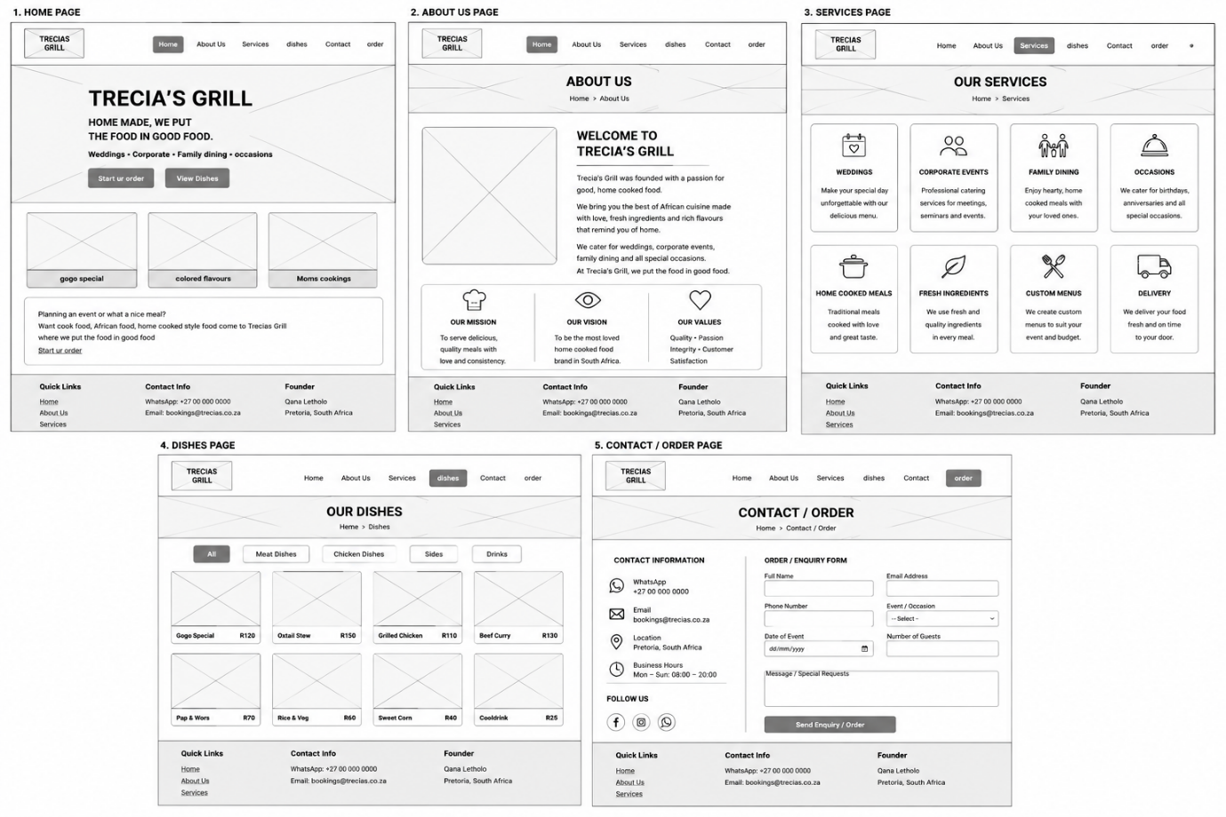
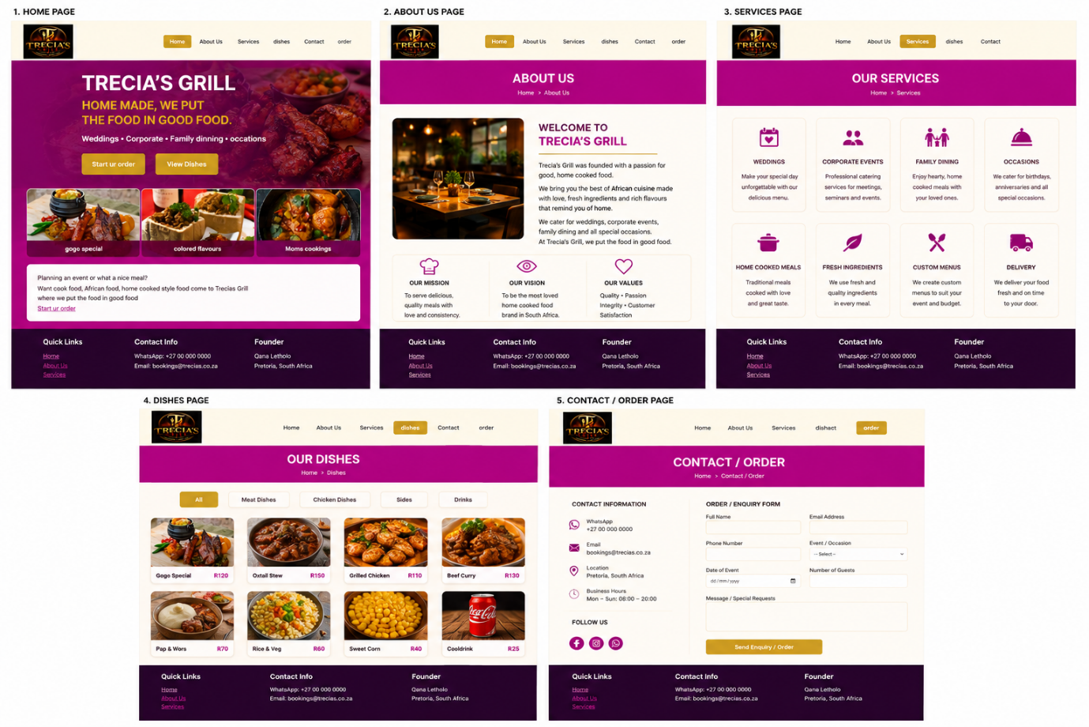

Bibliography
Android Developers, 2023. appllication fundamentals. [Online]
Available at: https://developer.android.com/guide/components/fundamentals
[Accessed 18 august 2025].
Business insider, 2022. business insider. [Online]
Available at: https://www.businessinsider.com
Chat gpt, n.d. chat gpt. [Online]
Available at: https://chatgpt.com/c/68a5aac2-8b18-8322-9c90-dc70680c1ec9
[Accessed 12 AUG 2025].
Rampamba, R., 2026. Mr [Interview] (5 8 2026).

